**Simple user instruction for using the code**

**Introduction**

The matlab codes in this folder implemented Phil’s methodology by EPID IMRT commissioning group to convert the EPID image from Siemens in dicom format and his images from Elekta to dose for IMRT QA. The main function is called EPIDDOSE.m. This function calls all other functions to complete the task.

**The main feature of programs:**

1. It will automatically convert the EPID images from Elekta or Siemens linac provided that all images for one patient were saved in one folder.
2. It will automatically choose the pixel factor based on the machine, for instance, M3 or M5 for Simens , M1 or M2 for Elekta.
3. The EPID dose files were named using patient name, gantry angle, image UID beam name etc.

**How to use it**

1. Open matlab and change directory to the code directory, type **EPIDDOSE.**
2. For Siemens, pickup the directory where the Siemens EPID files exits as shown below. Click ok, the program will finish the rest of job. The dose image files will be saved in the same folders.

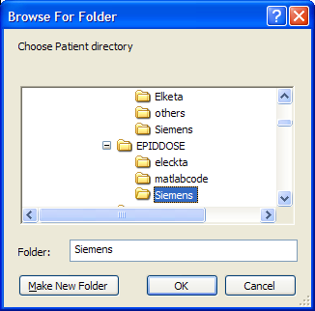

1. For Elekta, after you choose the patient folder, you will firstly pop up another window to ask you to choose the log file for all his image files as shown below. The log file does not have to be in the same folder as where the same image files are.

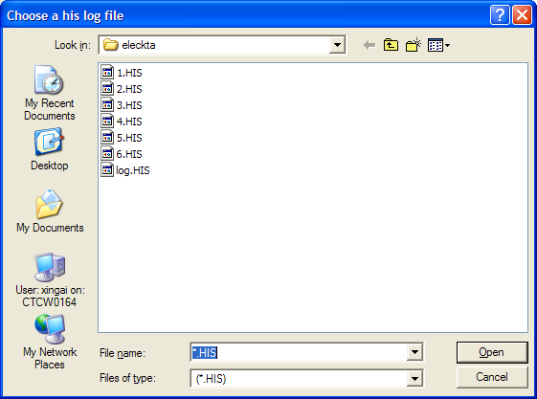

1. After you choose the log file, the next window to ask you to choose a template dicom file

exported from Elekta as shown below. The dicom file can be any file in any directory. Click

ok, then program will do the rest of job.

